Note: Manuals are optional. Not all policies require the creation of a manual. Fill in the necessary information and add sections as needed. Contact policy@rdpolytech.ca to determine if a manual is required for a policy.
Manuals may be posted on the Red Deer Polytechnic Policies web page.
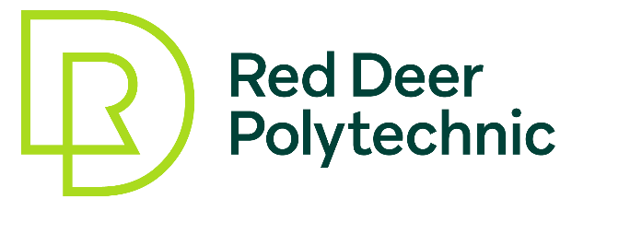
Manual Name
Parent Policy: Policy Name
Category: Administrative or Academic or Academic-Administrative | Approval Date:
Manual Owner: | Effective Date:
Manual Administrator: | Review Period:
Associated Documents
List any forms or other documents that are directly associated with the manual. These are the documents that a reader needs in order to understand how to do something in compliance with the policy. These will be hyperlinked for ease of access.

PURPOSE
To outline specific directions on how to implement and comply with the <Policy Name> and all associated documents. The information in this Manual does not supersede the detailed steps in the approved Procedures.

SECTION 1: SECTION TITLE

Sub-heading

SECTION 2: SECTION TITLE

Sub-heading

